FOCP C Programming Assignment
Module 2: Conditional Statements and Operators
Question 3: Grading Students
Platform: HackerRank
Programming Language: C
Problem Link: https://www.hackerrank.com/challenges/grading/problem
Problem Statement
HackerLand University follows a grading policy where every student receives a grade between 0 and 100.
Any grade less than 40 is a failing grade.
Sam rounds students' grades according to these rules:
- If the difference between the grade and the next multiple of 5 is less than 3, round the grade up to the next multiple of 5.
- If the grade is less than 38, no rounding occurs.
Given the initial grades of students, write a program to automate the rounding process.
Input Format
- The first line contains an integer n, the number of students.
- Each of the next n lines contains one integer representing a student's grade.
Constraints
- 0 <= grade <= 100
Sample Input
4
73
67
38
33
Sample Output
75
67
40
33
Explanation
- 73 is rounded to 75 because the difference is 2.
- 67 is not rounded because the difference is 3.
- 38 is rounded to 40 because the difference is 2.
- 33 is not rounded because it is below 38.
Source Code: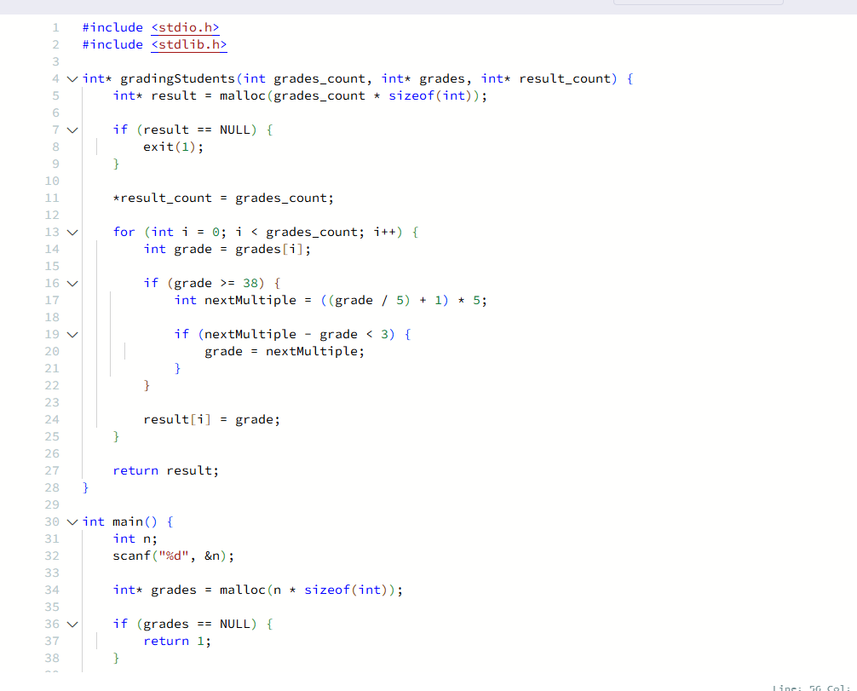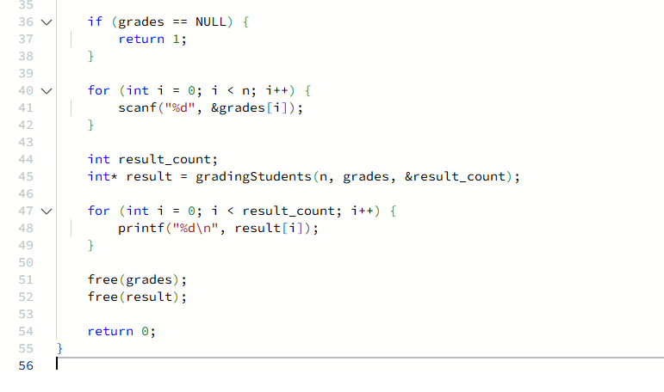

Output
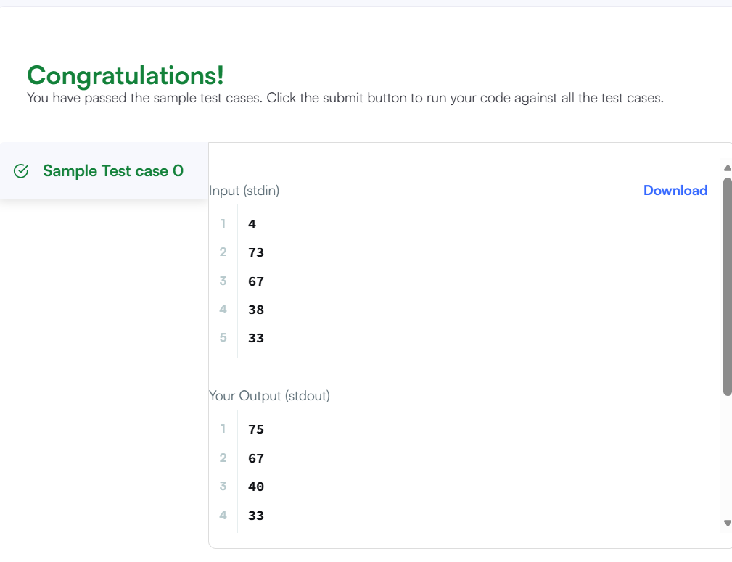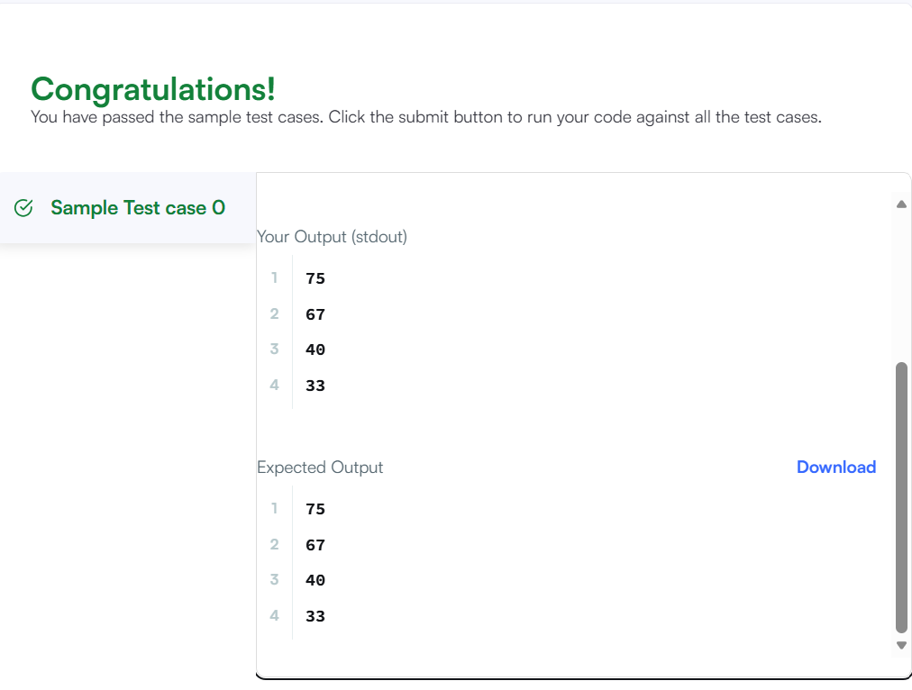Result
The program was executed successfully, and all test cases were passed on HackerRank.

